# Report for Landon Cox (2024-10-01 to 2024-10-31)

Average Bat Speed: 51.36

Average Rotational Acceleration: 7.34

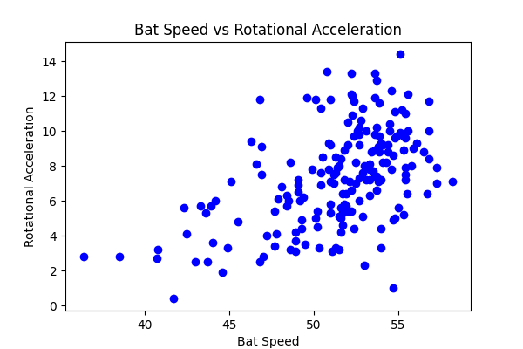

## Comments

Add comments here...